Task 01
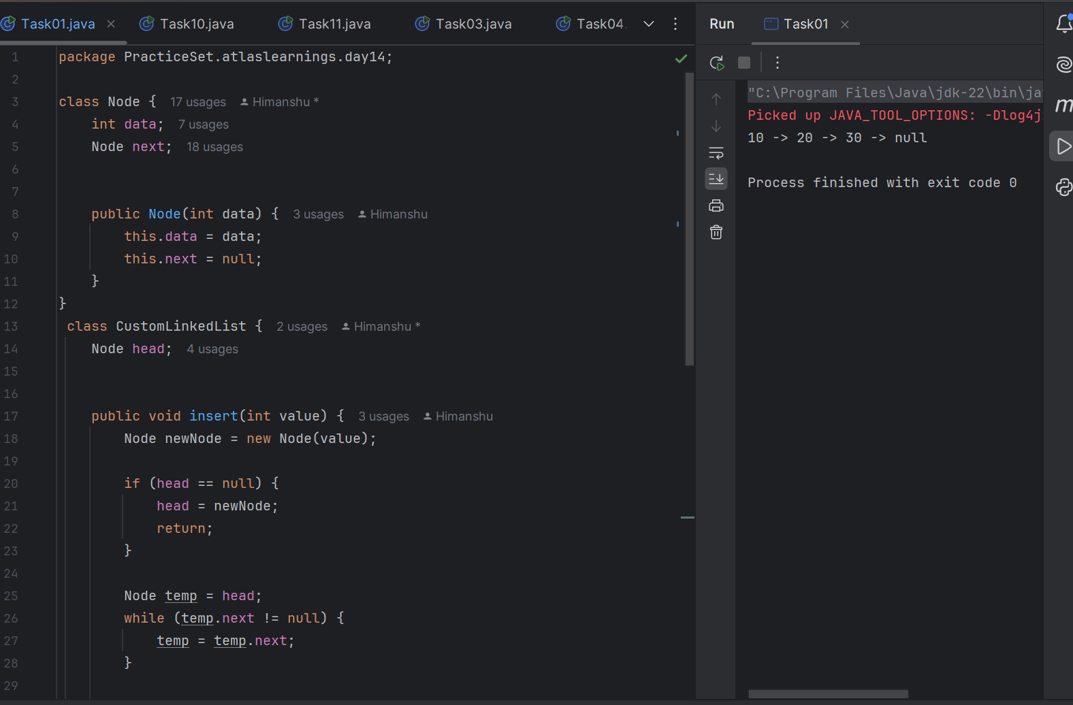
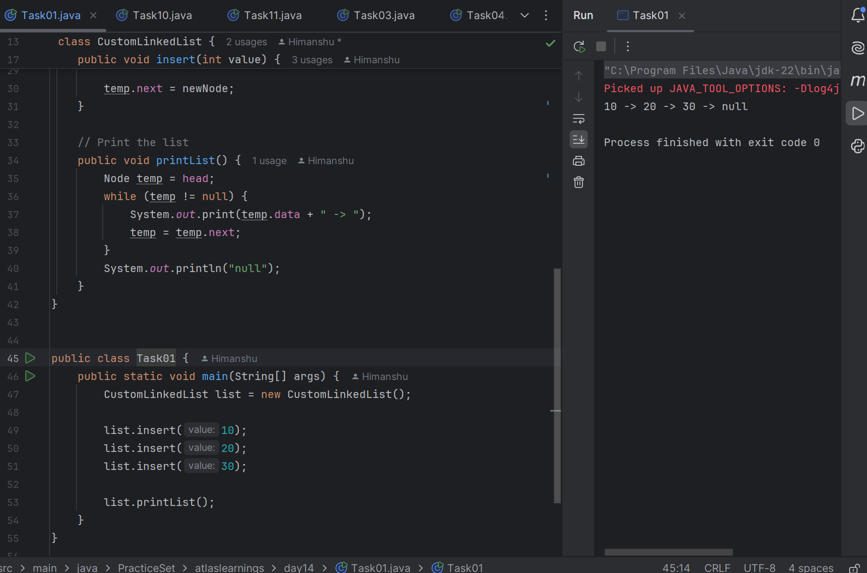

Task 02
In simple words, traversing means going through each element in a data structure one by one.

Task 03
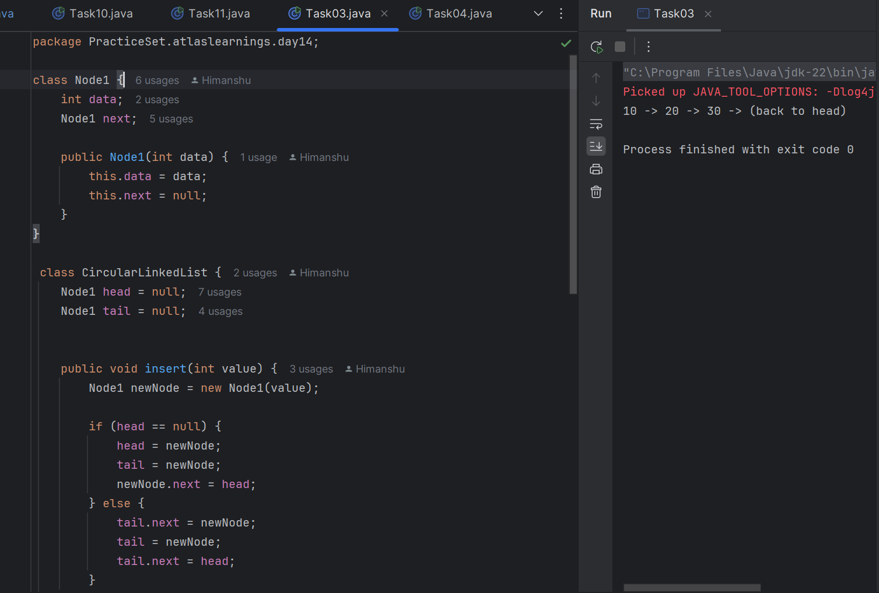

Task 04
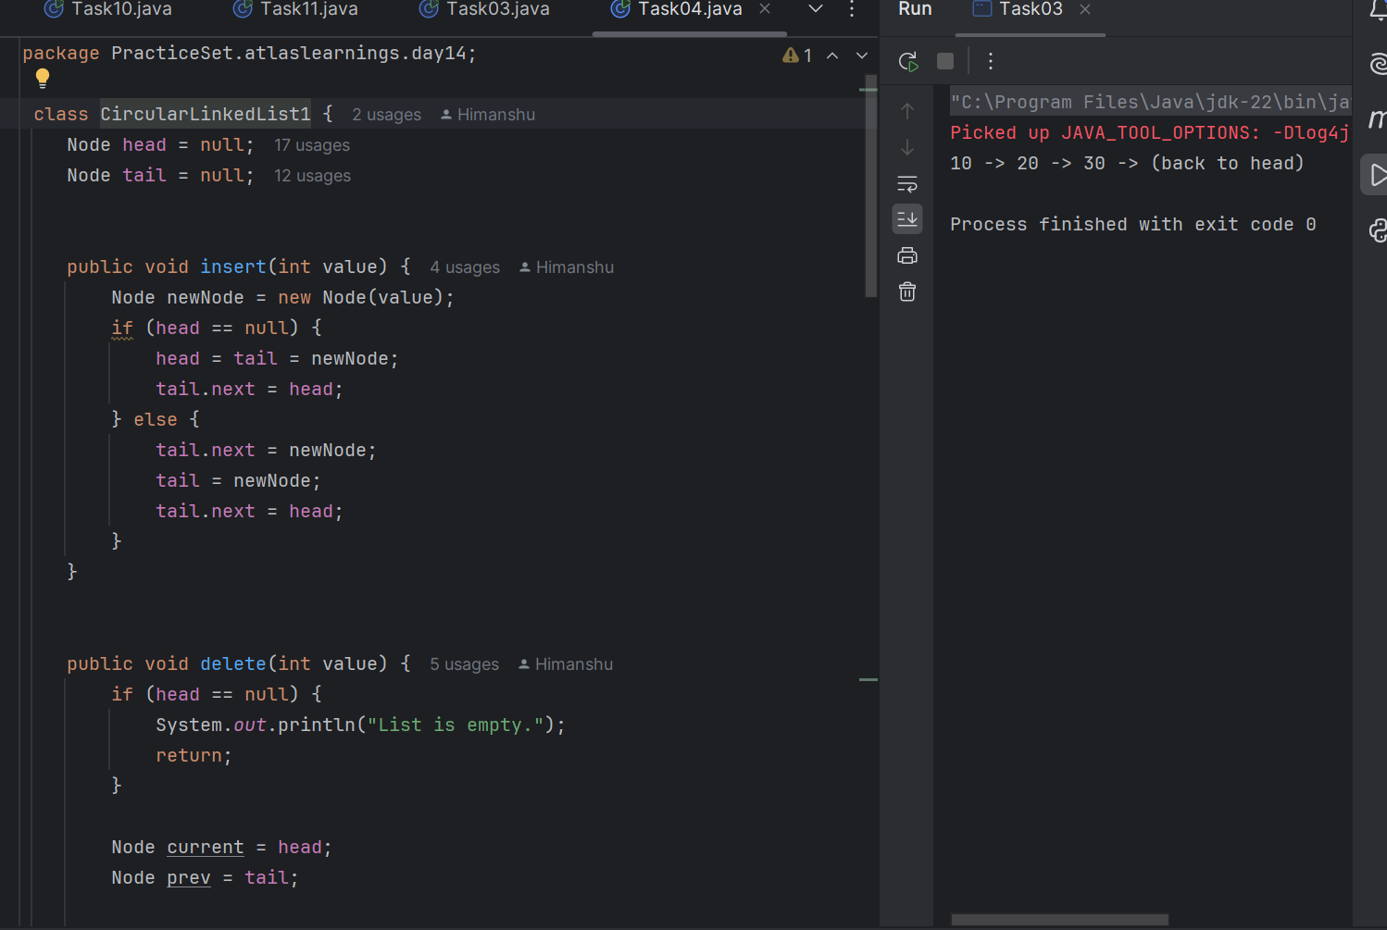
Task 05 - Task 08
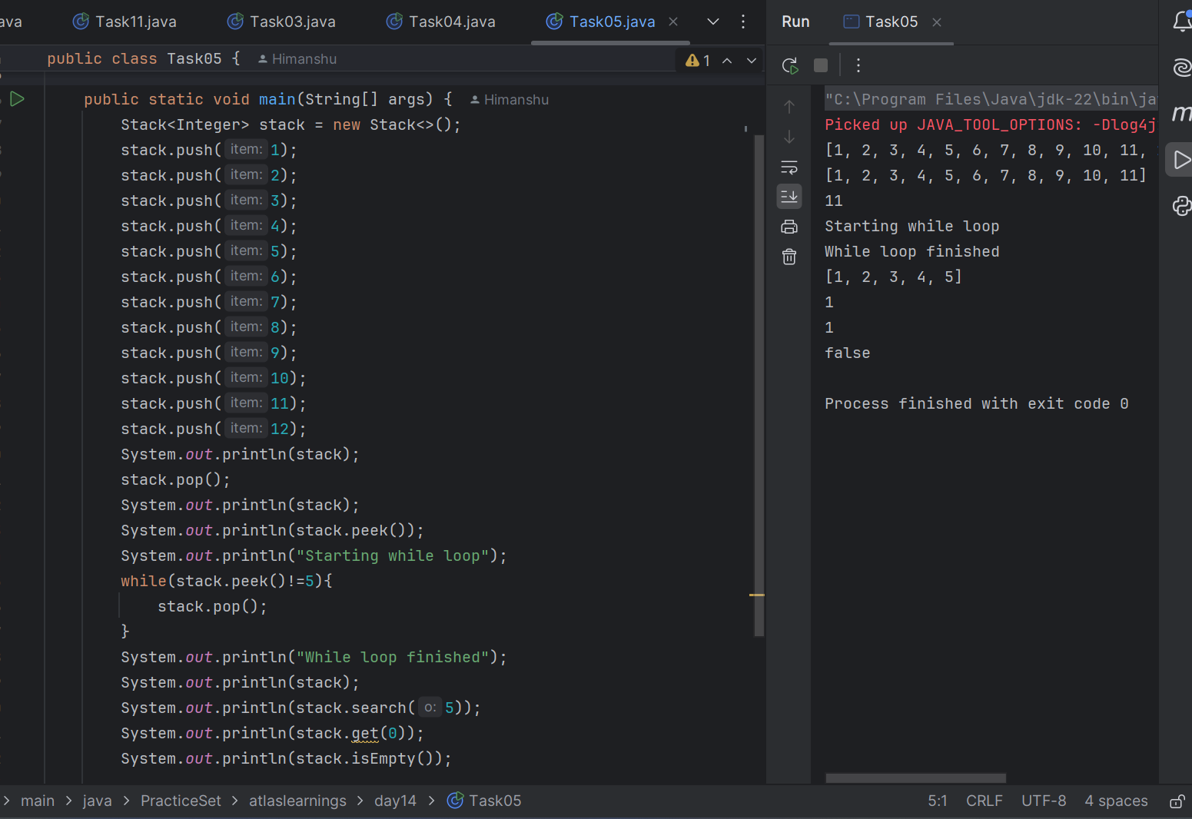

Task 09
push() Pushes an item onto the top of the stack.
pop() Removes and returns the object at the top of the stack.
peek() Returns the object at the top of the stack without removing it.
empty() Returns true if the stack is empty; otherwise, returns false.
search() Returns the 1-based position from the top of the stack where the object is located, or -1 if not found.
size() Returns the number of elements in the stack.
isEmpty() Checks if the stack is empty.
get(int index) Returns the element at the specified position.
remove() Removes the element at the specified position.
clear() Removes all elements from the stack.
contains() Checks if a specific element is present.
Task 10
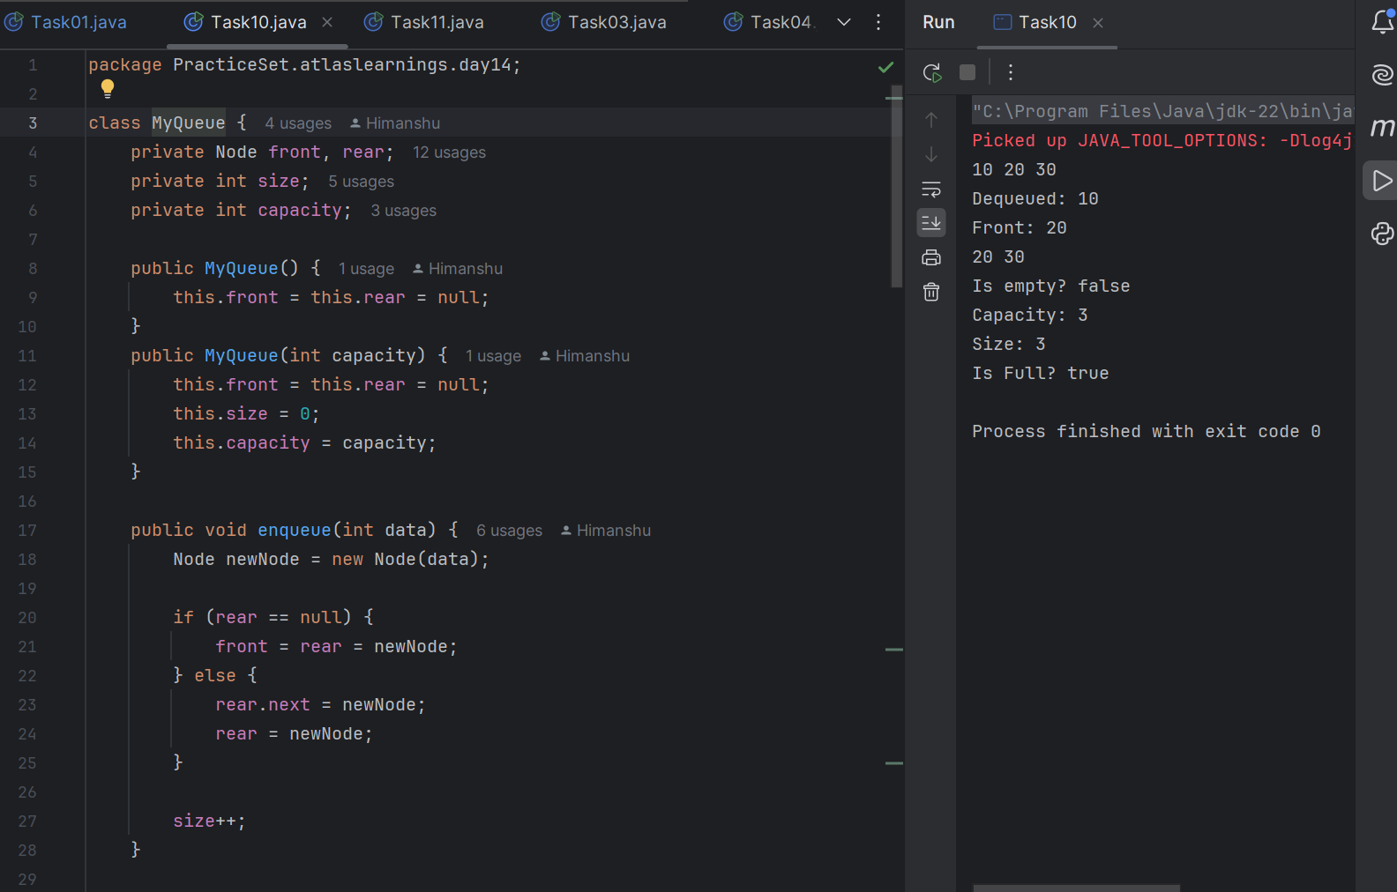
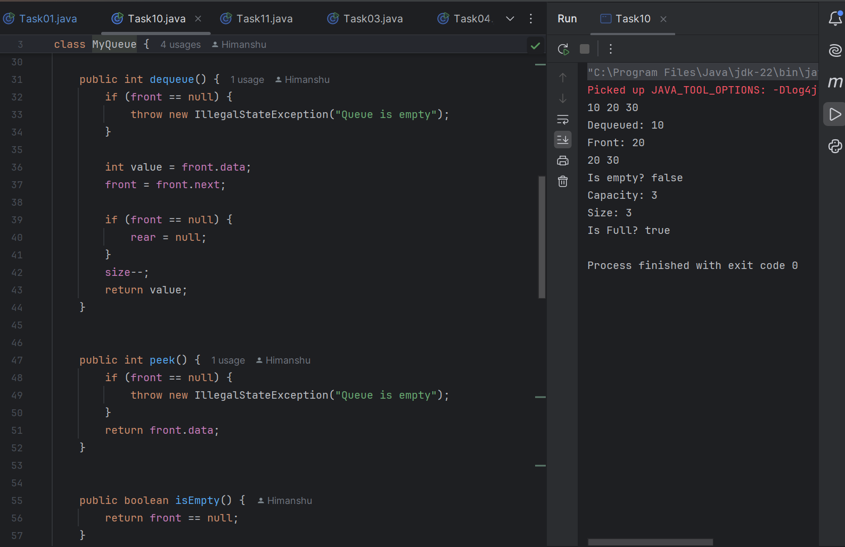
Task 11
